

FortnaPlus Control
Timers
and the
Timer Creation Wizard
Document Revision: 1.1
Date: 27-Jan-2023

Revision | Date | Author | Revision Summary
1.0 | Unknown | B C Conklin | New document
1.1 | 30-Jan-2023 | T R Kremser | Update and general refresh

Table of Contents
Glossary of Terms 4
1. Table ‘timemenu’ 5
2. The Create Timer Wizard 6
3. Fun Timer Facts 7

Confidential/Proprietary Statement
This document contains trade secrets and information that is considered confidential and proprietary to Fortna, Inc. It may not be duplicated, used, or disclosed outside the original recipient organization, and it may not be duplicated, in whole or in part, for any purpose other than to evaluate this document. Fortna Material Handling reserves the right to modify this document as necessary to reflect any terms and conditions negotiated and included as part of a subsequent contract or purchase order.

Glossary of Terms
AC – Automation Controller
FPC – FortnaPlus Control
UPS – Uninterruptible Power Supply

Table ‘timemenu’
The timemenu table (Configuration Menu | Standard Controls | Timers) displays each timer record as an individual page.
Timers are used extensively within FPC. They are used to monitor and control the status of Full eyes, Jam eyes, motor AUX contact, and many, many other things.
timemenu Table
Field | Type | Description
Timer_Name | String | Enter a unique name for the timer. The naming convention for automatically-generated timers always begins the name with ‘tm’. Full-clear timers will begin with ‘tmfc’. The remainder of the name will often be the name of the associated part, such as a full eye, or jam eye.
Timer_Address | Int | A long integer assigned by the timer wizard to uniquely identify this timer.
General_Description | String | Optional. Use this space to add more text to describe the purpose of this timer.
Invert | Y/N | Not used.
Start | Y/N | Set to Y to start timing. This is usually done under program control. Will be set to N as the timer starts.
Timing | Y/N | Set to Y by the software as the timer starts, and to N when it completes.
Keep | Y/N | Not used.
Done | Y/N | While a timer is timing, Accumulated is checked against Preset_Value. The software will set this to Y when Accumulated reaches Preset_Value. Timers that are not done are shown in RED. Timers that are done are shown in GREEN.
Retentative | Y/N | N = The timer is non-retentive. The timer is automatically reset each time the timer stops.  Y = The timer is retentive. It will hold the elapsed time (in Retained) if the timer is stopped, and resume when it is restarted.
Reset_Bit | Y/N | Setting this to Y resets the timer so it will start again at the Preset_Value time. This is true for both non-retentive and retentive timers.
Preset_Value | Time | Enter the duration for the timer.
Accumulated | Time | When the timer runs, this field will show the elapsed time.
Retained | Time | For retentive timers, this field shows the time accumulated while the timer was running and, if stopped, indicates where the timer will pick up when restarted.
Start_Time | Time | Not used.
Owner | PopUp | Optional. Choose an owner from the Machine table.
Changed | Y/N | Internal flag used in conjunction with the “Check Local Timers” batch job to flag any timers that have changed so they can be updated in MySQL table timelist. The function is also called every time a timer configuration is manually changed in table timemenu even if the batch job is not configured. The corresponding batch job “Check Timers Changed” can be used by other ACs to read the changes from the database and update the local copy of timemenu. This is usually not necessary.

The Create Timer Wizard
You can access the Create Timer wizard through Configuration Menu | Wizard Utilities | Create Timer.
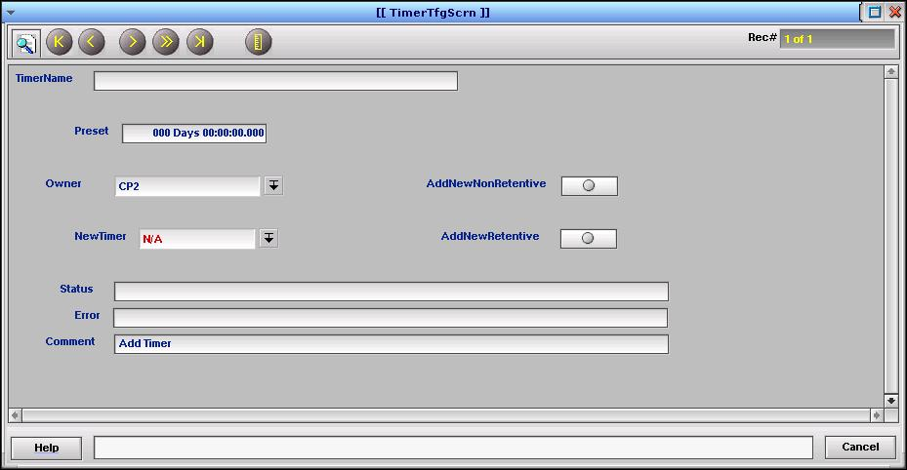
To add a new timer, give it a unique, descriptive name in the TimerName field, adjust the Preset value, and assign an Owner AC, then click either AddNewNonRetentive or AddNewRetentive to create the timer. The new timer will appear in the NewTimer field. You can easily open the timemenu table by right-clicking the down-arrow beside the field.
Once created, you can adjust any of the fields, as required, from table timemenu.

Fun Timer Facts
When creating new timers manually, it is best to follow the naming conventions.
The default Preset time in the wizard is 3 seconds.
Full timers are configured as non-retentive because each time the full photoeye is unblocked, the timer must be reset to be ready for the next container.
Jam timers are configured as retentive to help prevent equipment damage if a jam is in the process of being detected when the line is stopped. The accumulated time is retained so only the remainder of the time must elapse when the line is restarted before a jam is declared.
When entering time values into fields like Preset in the wizard or Preset_Value in table timemenu, you can follow the format shown to enter the time in Days Hours, Minute, Seconds, and fractions of a second, like “000 Days 00:02:07.123”, or if you enter just a numeric value, like 127.123, it will be interpreted as seconds. The examples given represent the same value, and, if entered as a numeric value, will be displayed in HH:MM:SS.SSS format once accepted.

